07th March 2017

**YOKOHAMA Launches “BluEarth-Es ES32” New Fuel-Efficient Global Standard Tyre Loaded with Japanese Technologies**

YOKOHAMA announced today that it will begin sales of a new fuel-efficient global standard tyre, the “BluEarth-Es ES32 (BluEarth-Es)” from this spring. The new tyre will initially be rolled out in Europe, Asia and Oceania, with marketing to gradually expand to the Middle East and Latin American markets (the new tyre will not be sold in some countries, including Japan, China, India and Russia). “BluEarth-Es” will be available in a total of 73 sizes, ranging from 235/40R18 95W XL to 175/70R13 82T. Responding to the recent trend toward tyres with larger rim diameters (inches), the “BluEarth-Es” series will include a number of size variations with 17-inch and 18-inch rim diameters.   
  
“BluEarth-Es” provides a well-balanced package of the four core performance traits of any tyre – wet grip, wear resistance, durability, and fuel efficiency. It features a new tread pattern with a wide, square, powerful profile that delivers stable driving performance and safe handling. “BluEarth-Es” uses Yokohama Rubber’s proprietary “nano BLEND compound” comprising various materials, including orange oil, which creates an optimal balance of high fuel efficiency, superior wet grip performance, and wear resistance. The original “orange oil” makes the tyre’s rubber more pliant, which results in an optimal contact area between tyre and road, thereby reducing uneven wear.   
  
“BluEarth” is YOKOHAMA’s “environmentally, human and socially friendly” global tyre brand realizing not only excellent environmental performance, but reducing specific burdens on drivers, passengers and surrounding living environments – friendly performance. The“BluEarth-Es” is one of the latest additions to YOKOHAMA’s “BluEarth” lineup in Europe, which already includes the high-performance and fuel-efficient “BluEarth-A” as well as the series’ new grand touring tyre developed especially for crossover utility vehicles (CUVs) and multipurpose vehicles (MPVs), the“BluEarth RV-02”, which will be launched this summer.

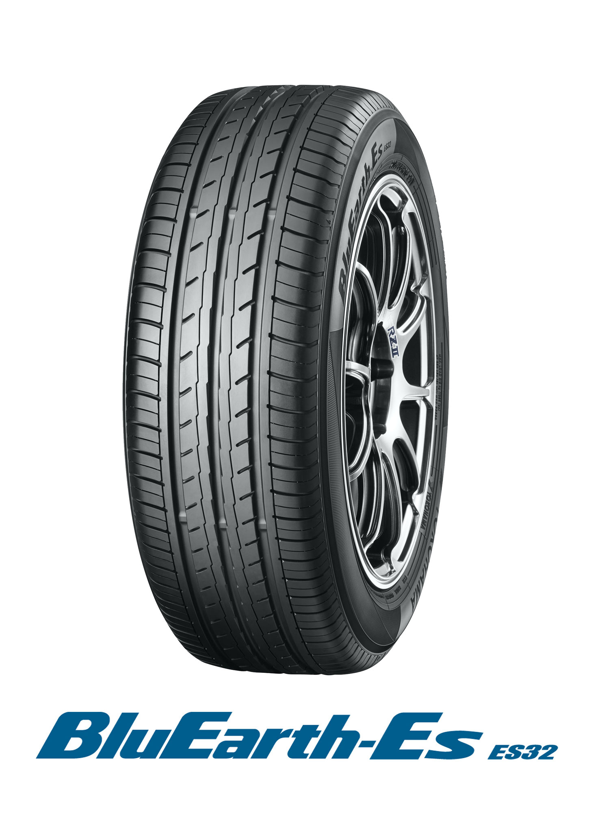

*BluEarth-Es ES32*